1. Create user with name Techie and provide sudo access to user.

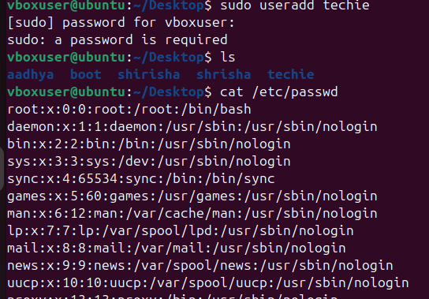

1. Navigate to the home directory.

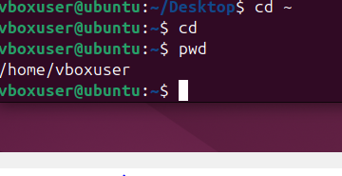

1. Create a new directory.

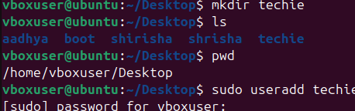

1. List the contents of a directory.

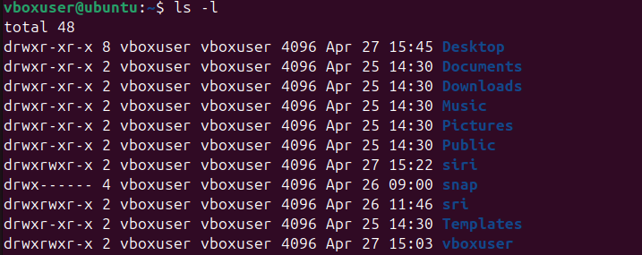

1. Change the current directory.



1. Create a new empty file.

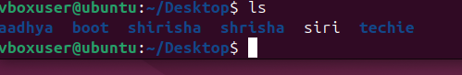

1. View the contents of a file.

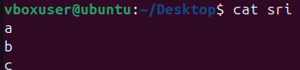

1. Copy a file to another location.

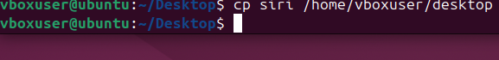

1. Move a file to another location.



1. Rename a file.

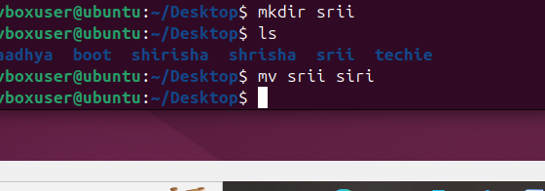

1. Delete a file.

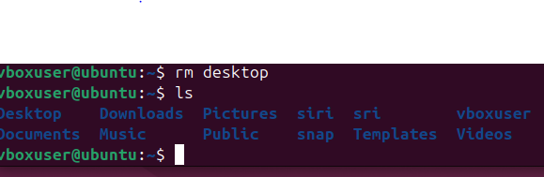

1. Grant or revoke permissions on a file or directory.

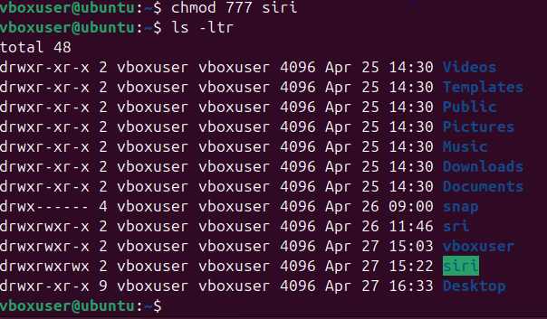

1. View the current date and time.



1. Check the system uptime.

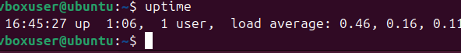

1. View the running processes.

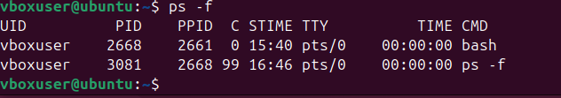

1. Kill a running process.



1. Install a package using the package manager (e.g., apt or yum).

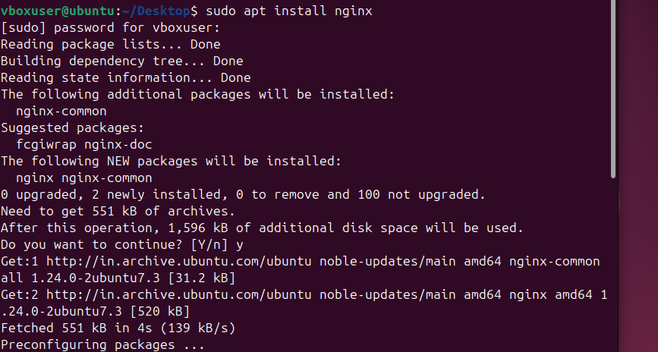

1. Update the system packages.

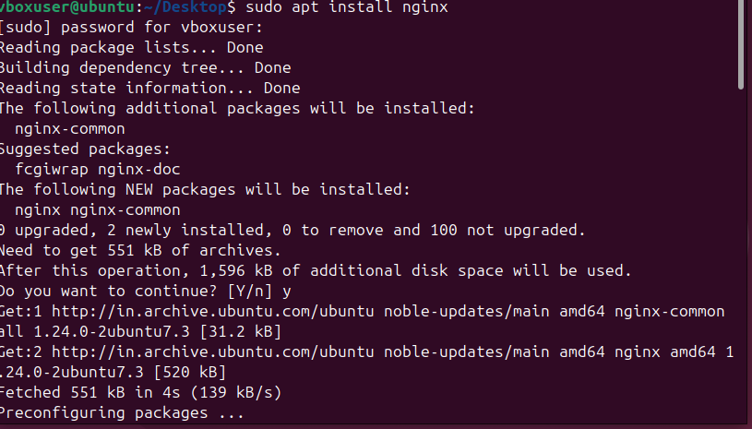

1. Create a symbolic link.

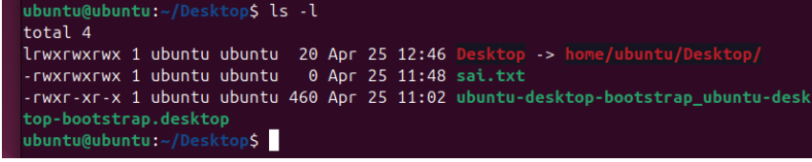

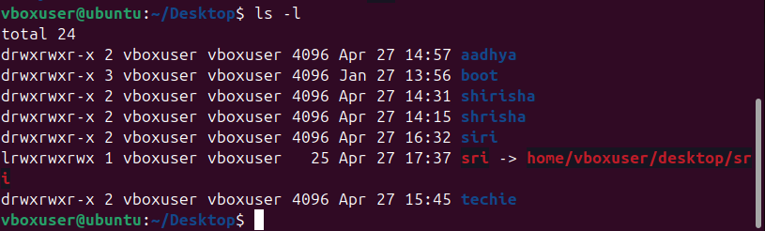

1. Search for files using the find command.

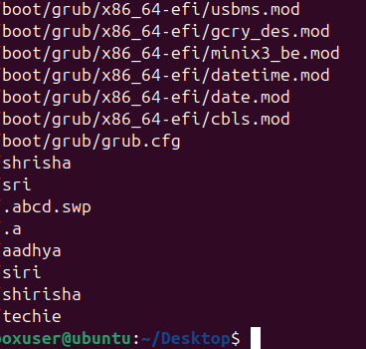

1. Compress and decompress files using tar.



1. Monitor system resources with top or htop.

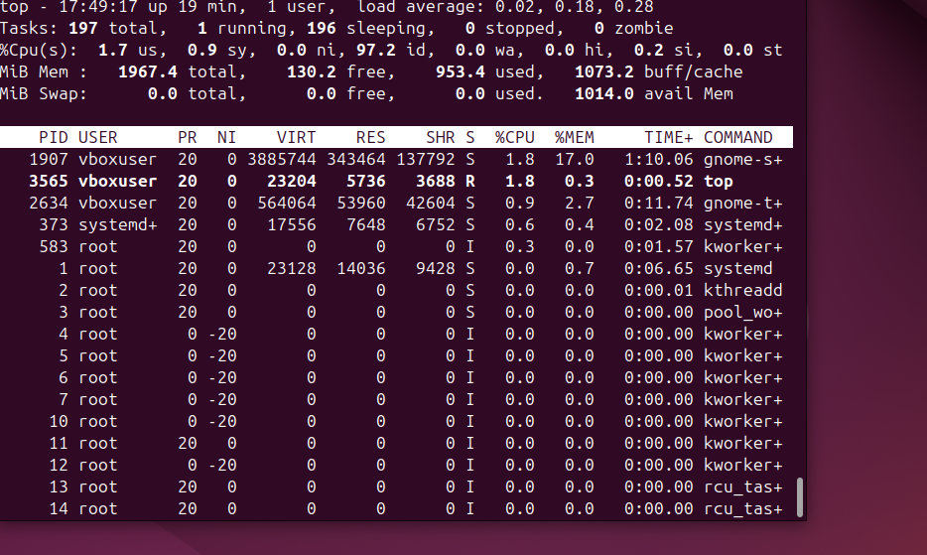

1. Create and manage user groups.

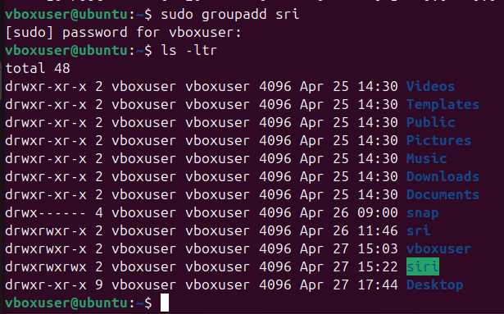

1. Set up SSH password less authentication.

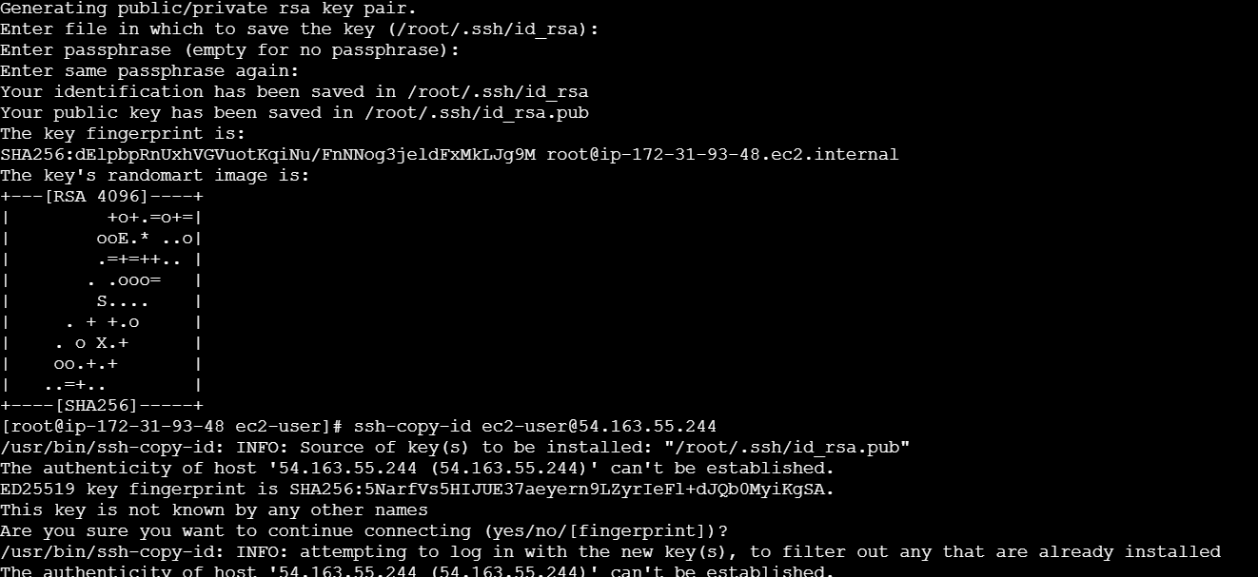

25) Monitor log files using tail or grep.

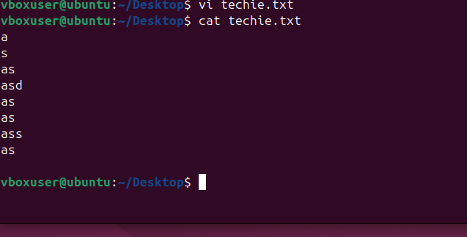

1. Set up a web server (e.g., Apache or Nginx).

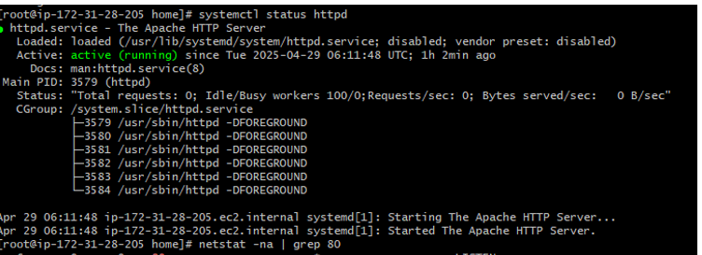

1. Configure and secure a MySQL Database.

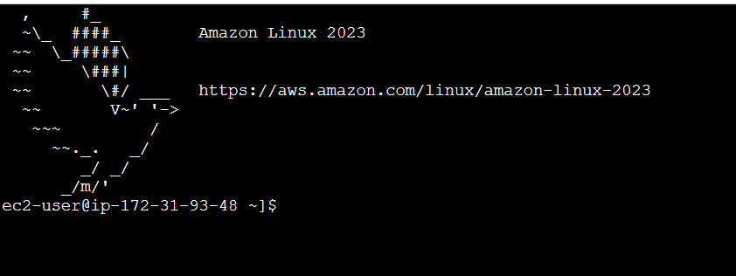

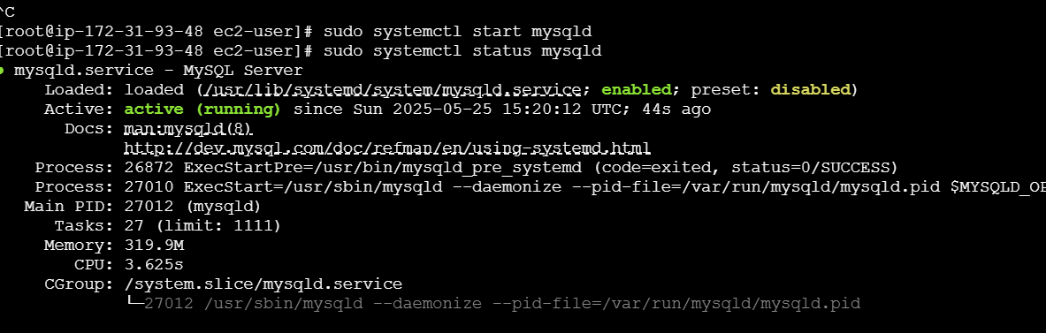

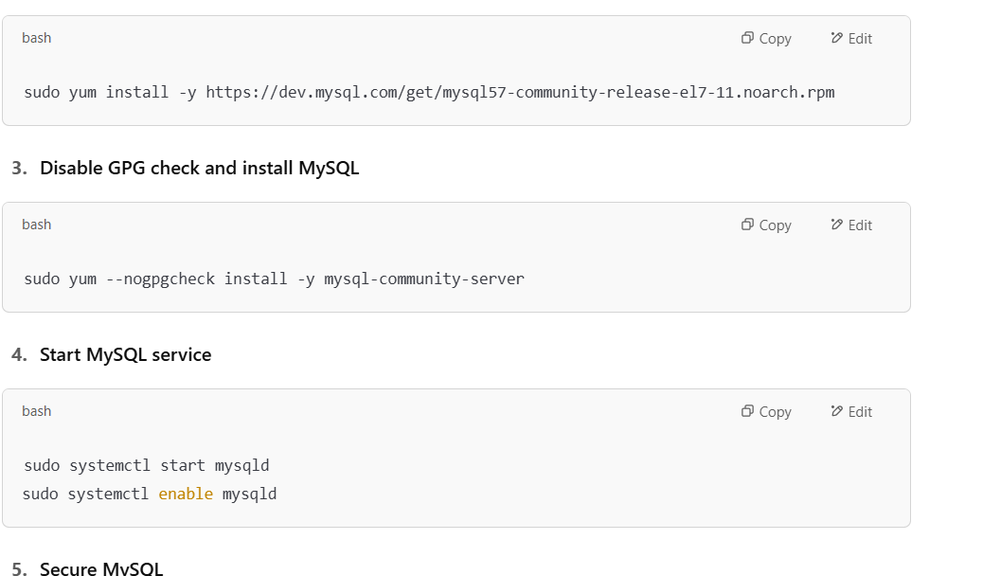

28) Set up a Application Server (e.g.,Apache Tomcat)

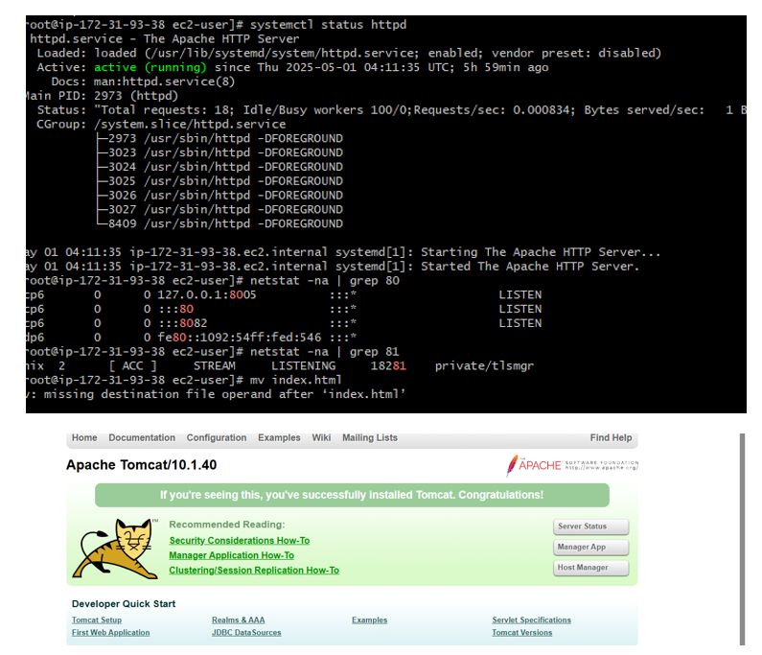

29) create a service file for Apache Tomcat.(Should execute by using systemtctl command)

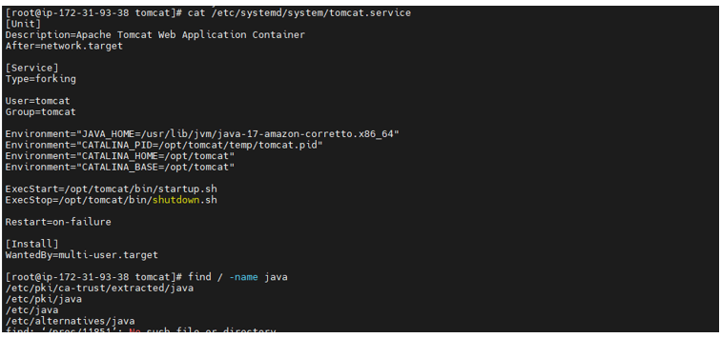

30) Print specific columns from a delimited file.



31) Filter and print lines based on a specific pattern or condition.

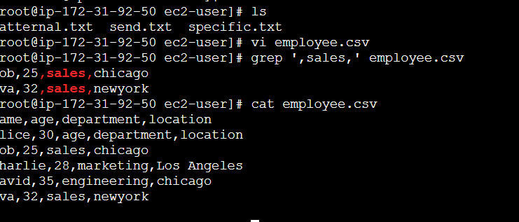

32) Calculate and print the average, sum, or other statistics of a column.

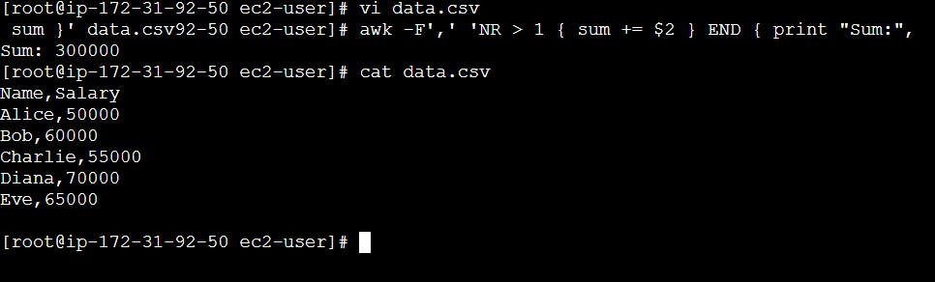

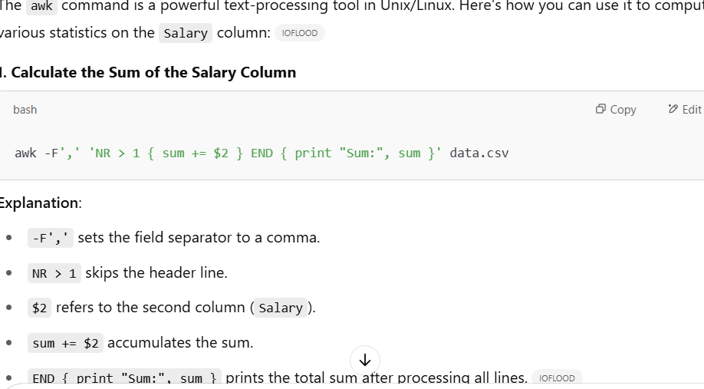

33) Perform string manipulation, such as extracting substrings or changing case.

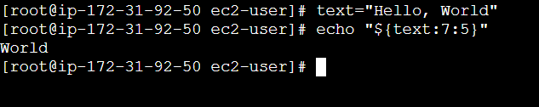

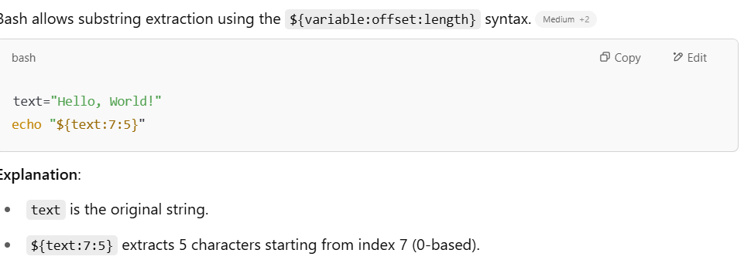

34) Count the occurrences of a specific pattern in a file. 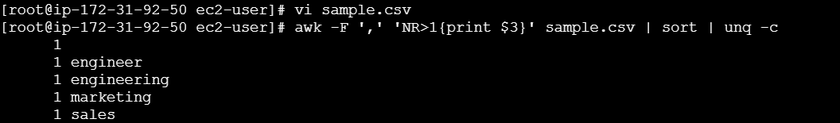

35) Sort lines based on a specific field or column.

Sort the data by:

Age (2nd column) — numerically

Department (3rd column) — alphabetically

1) Sort by Age (column 2) numerically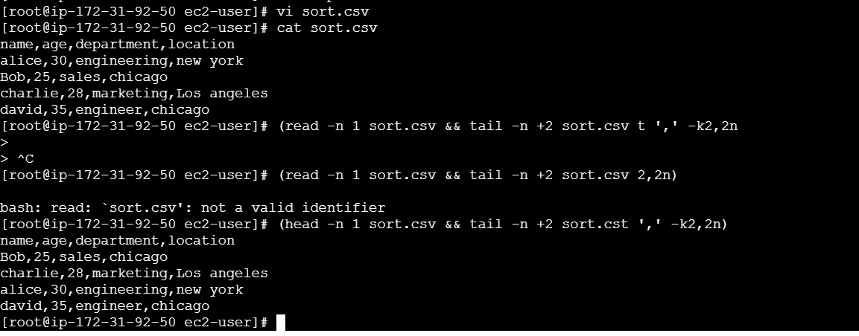

36) Merge multiple files based on a common field or column.

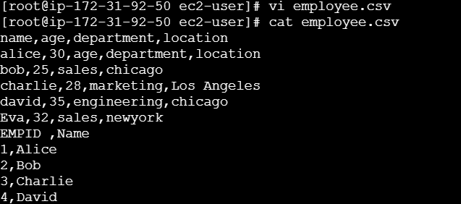

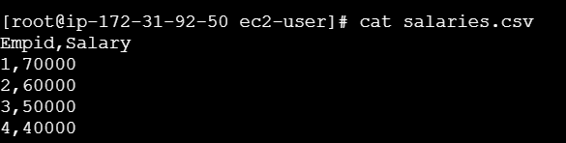

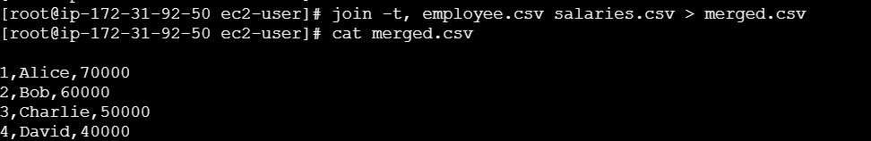

37) Substitute text in a file using search and replace.

38) Delete specific lines based on a pattern or line number.

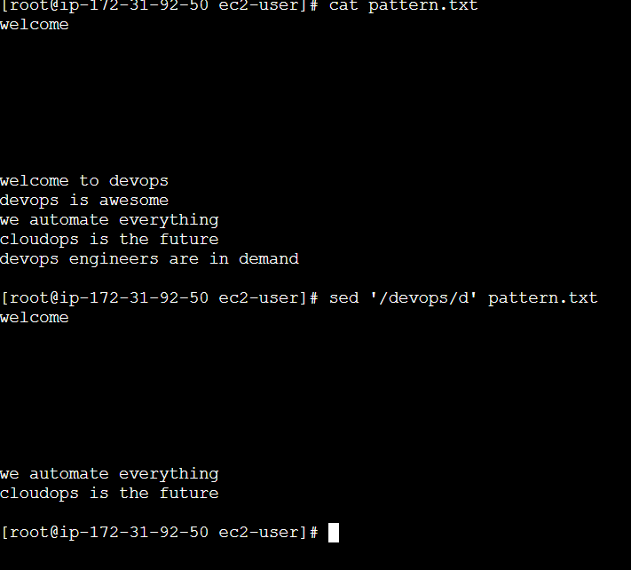

39) Append or insert text before or after a specific pattern or line.

1) Insert a line before any line that contains "devOps".

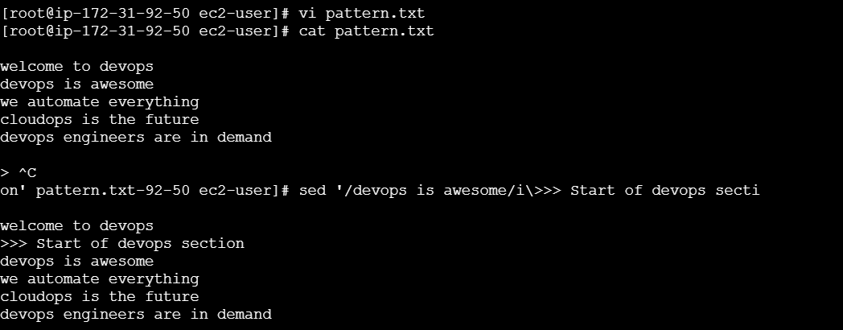  
2) Append a line after a line that contains "cloudOps".

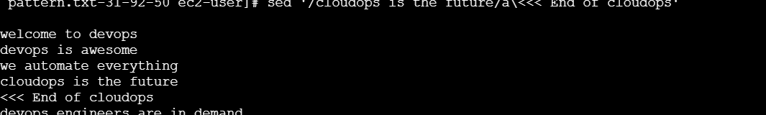

40) Print only specific lines from a file.

Print a specific line number (e.g., line 3)

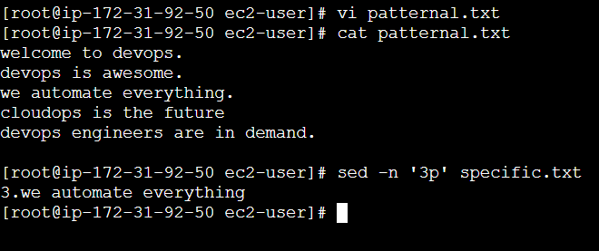

41) Copy file from linux to windows machine

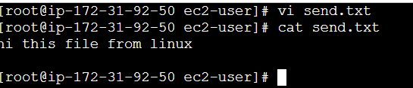

42) 5 use cases for AWK and 5 use cases for sed

1. Print Specific Columns

Scenario: You have a file with multiple columns, and you want to display only selected ones

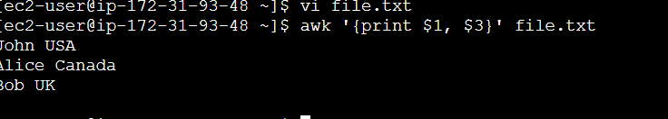

**2. Calculate Sum of a Column**

**Scenario:** You want to calculate the total of the second column (e.g., ages).



3. Filter Lines with Conditions

Scenario: Show only lines where age is greater than 25.

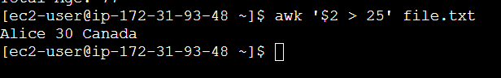

**4.Count Words, Lines, and Characters**

**Scenario:** You want to count how many lines, words, and characters are in a file



**5.Add Headers and Footers**

**Scenario:** You want to generate a report with a title and end line.

